

**American International University-Bangladesh**

**CSC 2211 - Algorithms, Sections - C, D and G, Summer 2022**

**Final Term Assignment**

**Problem 1 (Mathematician)**

Consider that a **mathematician** friend of yours has discovered a new series. The first 3 terms of this series are 1, 2 and 3. All the other terms of this series can be found by multiplying the previous 3 terms. For example, the 4th term of this series is equal to the product of the 1st term, 2nd term and 3rd term i.e. 1 x 2 x 3 = 6 and the 5th term is equal to the product of the 2nd term, 3rd term and 4th term i.e. 2 x 3 x 6 = 36.

1. Modify the Divide and Conquer algorithm (program) for finding the n-th term of the Fibonacci series to develop a code for finding the n-th term of the above series.
2. Write down an algorithm (program) that uses the Top Down with Memoization Dynamic Programming algorithm design technique to find out the n-th term of the above series.
3. Write down an algorithm (program) that uses the Bottom Up Dynamic Programming algorithm design technique to find out the n-th term of the above series.
4. Which algorithm(s) or program(s) - one from part (a), part (b) or part (c) solve the same subproblems over and over again? Explain with an example.
5. Which algorithm (program) or algorithms (programs) - one from part (a), part (c) or part (d) - do not make use of computer memory in order to save time? Which algorithm (program) will take the longest amount of time to find the n-th term of the above series and which will take the least amount of time? Explain.

**Problem 2 (Chowdhury Saheb)**

Consider that **Chowdhury Saheb** is a Zamidar who has lands in different places of Bangladesh. Recently Chowdhury Saheb is thinking of selling off some of his properties. Following is a list of his lands including price and size of each.

Properties: {Land in Chattagram, Land in Sylhet, Land in Dhaka, Land in Rajshahi}

Size in Bighas: { 5, 5, 6, 4 }

Price in Crores of taka: {6,5,9,7}

Chowdhury Saheb is worried about 2 laws related to selling of land properties.

The first law states that no one will be able to sell a total of more than **10 Bighas** of land in a year.

The second law states that while selling off a land, a person must sell the **full land**. For example, if Chowdhury Saheb wishes to sell his lands in Chattogram and Sylhet, he must sell all of Chattagram and Sylhet lands i.e. 5 bighas + 5 bigha = 10 bighas. But he cannot sell some portions of those lands such as 1.5 bighas from Chattogram and 0.5 bighas from Sylhet.

1. At a first glance the problem of finding out the maximum total money that Chowdhury Saheb can earn by selling his lands in a year may seem to be solvable using multiple algorithms. But one particular law from the two laws mentioned above narrows the appropriate choice of the algorithm to just one algorithm. Which law is this? Also use this law to justify the use of the algorithm that you will apply to solve the above problem.
2. Write down the algorithm that you suggested in response to part (a) and also dry run it line by line in order to find out the maximum total money that Chowdhury Saheb can earn by selling his lands in a year.
3. A friend of yours who have also taken the Algorithms course thinks that the algorithm that you suggested in response to part (a) uses the incremental design technique? Do you agree with him? Explain.

**Problem 3 (Onusondhan)**

Consider that a new Search Engine Company named ***Onusondhan*** has hired you to design an algorithm for them so that they may use it to print the maximum number of common characters that appear in the same order in a user entered search string and the content of a web page. For example, if the user-entered search string is “CAT” and a web page contains the string “TAB”, then the maximum number of common characters appearing in the same order are - “A” or “T”.

1. Can you use simple string comparison algorithm that compares 2 strings and can only find out whether they are a complete match or not to solve the above problem? Explain.
2. Which algorithm will you use to print the maximum number of common characters that appear in the same order in a user entered search string and the content of a web page? For example, if the entered search string is “CAT” and the web page contains the string “TAB”, then your algorithm should print “A” or “T”.
3. Does your suggested algorithm from part (b) need help from any other algorithm? If yes then which one is it?
4. Write down your mentioned algorithm from part (b). Also if you think that your algorithm from part (b) needs help from some other algorithm then write down that algorithm as well.
5. Dry run the algorithm or algorithms from part (d) to print the maximum number of common characters that appear in the same order if the user entered search string is “CAT” and the content of a web page contains the word “TAB”.
6. Which algorithm design technique is used by the algorithm or the algorithms that you have written in response to part (d)? Justify.

**Problem 4 (SPARRSO)**

Consider that in the not so distant future, **Bangladesh Space Research and Remote Sensing Organization (SPARRSO)** is planning to build several human habitats on Mars. SPARRSO is also planning to connect these locations using several tunnels. The following graph shows the human habitats (vertices) and the possible tunnels (edges) that may be used to connect those habitats. The edge weights of the graph, all of which are equal to 3, represent the lengths of the tunnels. Note that SPARRSO wants to minimize the total cost of building the tunnels and also wishes to connect all the Martian habitats or locations.

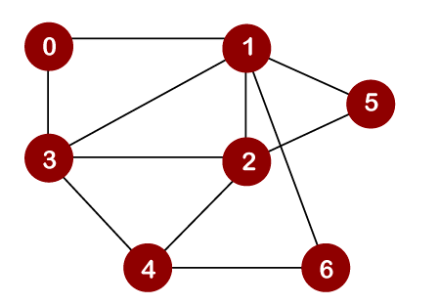

(a) Can you apply the Dijkstra’s Shortest Path Algorithm to find out the tunnels which if built will connect all the habitats at the minimum possible cost? Explain your position.

(b) If your response to part (a) was No then which algorithm or algorithms may be used to solve the problem faced by SPARRSO? Justify.

(c) Write down the algorithm or algorithms that you have mentioned in response to part (b). If you have written multiple algorithms then in which way are they different from one another?

(c) Dry run the algorithm or algorithms that you have written in response to part (c) and solve the problem faced by SPARRSO.

(e) The friend of yours who have earlier suggested that the algorithm in problem 2 uses the incremental design technique now believes that the algorithm or the algorithms that you have written in part (c) make use of the dynamic programming design technique? Do you agree with him? Explain.

**Problem 5 (Facebook)**

Consider that the social network giant **Facebook** has hired you to design an algorithm that will be able to print the connection between the writer and viewer of any posts on the network. For example, given the following graph where every vertex represents a person and every edge represents friendship between two individuals, if person 3 writes a post and if that post is visible to person 5 then your algorithm should print that person 5 or the viewer of the post is friend of person 2 and person 2 is friend of the writer of the post i.e. person 3.



(a) Write down two appropriate algorithms - the first of which will traverse the graph in a level by level approach and the second of which will use the parent array generated by the first algorithm to print the connection between the writer and the viewer of a post.

(b) Dry run your algorithms from part (a) line by line to print the connection between the writer of the post, person 3, and the viewer of the post, person 5.

(c) Is there any other algorithm that could be used instead of the first algorithm that you have written in response to part (a)? If yes then in which way is this new algorithm different from the first algorithm that you have written in response to part (a)?

(f) How is a graph represented in a computer? Represent the above graph using at least two different methods.

**Problem 6 (Computer Network)**

Consider the following graph that represents a **computer network**. The vertices of this graph represent different network nodes whose job is to send and receive information. The edges on the other hand represent the connection between the network nodes. Edge costs or weights represent the congestion between two nodes. The higher the congestion the lower the speed of information travelling between the nodes and vice versa.

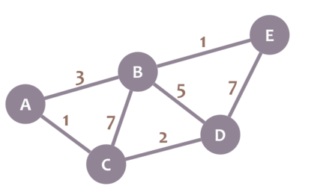

(a) Is it mandatory for us to use the Bellman Ford Algorithm or the Floyd Warshall algorithm if we just want to find out the maximum speed path from node E to node A? If not then which algorithm will be sufficient to solve this problem? Explain your position.

(b) Write down the algorithm that you have mentioned in response to part (a) as the one sufficient for solving the given problem.

(c) Dry run your algorithm from part (b) line by line to show the maximum speed path from node E to node A.

(d) The friend of yours from Algorithms course believes that the algorithm that you have written in response to part (b) uses the greedy algorithm design technique. Do you agree with him? Justify.